UX Feedback Report

Project: Realty Hub

Design Principles: Nielsen & Molich's 10 Design Principles

Introduction:

Nielsen and Molich's 10 Design Principles, also known as the 10 Usability Heuristics, are a set of guidelines for user interface design. These principles were developed by Jakob Nielsen and Rolf Molich in the early 1990s and have since become widely recognized and adopted in usability engineering. These principles help designers identify potential usability issues and create interfaces that are intuitive and user-friendly. Here are the 10 principles:

Visibility of system status: The system should always provide feedback to users about what is happening, keeping them informed about the status, and providing appropriate feedback for their actions. This helps users understand the system's response and prevents confusion or uncertainty.

Match between system and the real world: The system should speak the language of its users, using familiar concepts, terminology, and conventions. It should be consistent with the user's mental model and mimic real-world interactions, making it easier for users to understand and use the system.

User control and freedom: Users should have the freedom to explore and interact with the system without fear of making irreversible errors. It should provide undo and redo options, as well as clear and easy ways to exit or cancel actions. This helps users feel in control and encourages exploration.

Consistency and standards: The system should follow established conventions, both within itself and in relation to other similar systems. Consistency in design, terminology, and interaction patterns allows users to transfer their knowledge and skills from one part of the system to another or from other systems they are familiar with.

Error prevention: The system should be designed to prevent errors or make it easy for users to recover from them. By offering clear and understandable error messages, confirming potentially destructive actions, and guiding users towards correct inputs, the system can minimize errors and enhance the user experience.

Recognition rather than recall: The system should aim to reduce the user's memory load by making information and options visible and easily accessible. Users should not be required to remember information from one part of the interface to another but rely on visible cues and prompts for guidance.

Flexibility and efficiency of use: The system should accommodate different user needs and levels of expertise. Experienced users should be able to perform tasks more quickly through shortcuts or advanced features, while novice users should still be able to accomplish tasks using basic functionality.

Aesthetic and minimalist design: The system's interface should be visually appealing, with only essential elements displayed. Excessive information or clutter can distract users and make it harder to find what they need. A minimalist design focuses on the core features and functions, enhancing the user's ability to focus and make decisions.

Help users recognize, diagnose, and recover from errors: Error messages should be clear, precise, and provide guidance on how to correct the error. The system should explain the problem in plain language and suggest steps for recovery, helping users overcome obstacles and continue their tasks.

Help and documentation: The system should provide readily accessible and comprehensive documentation to support users in understanding and using the system effectively. Help materials should be easily searchable and offer clear instructions and explanations, allowing users to find assistance when needed.

Poll and user reviews:

I have conducted a poll to gather comprehensive data from different users, who gave their opinion of the website. The questions asked were about the design and overall navigability and ease of use. Here are the questions asked in the poll.

1.Do you find the website easy to navigate?  
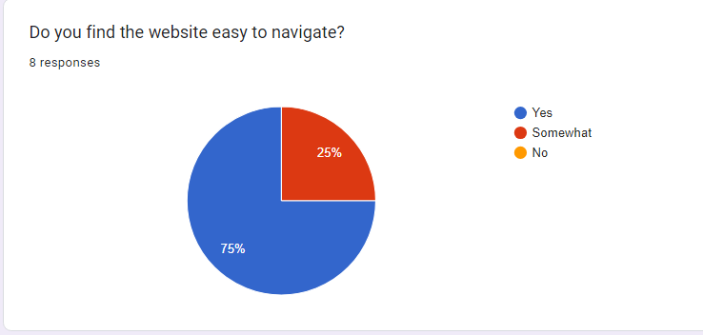

2.Does the website design looks easy to understand and pretty?  
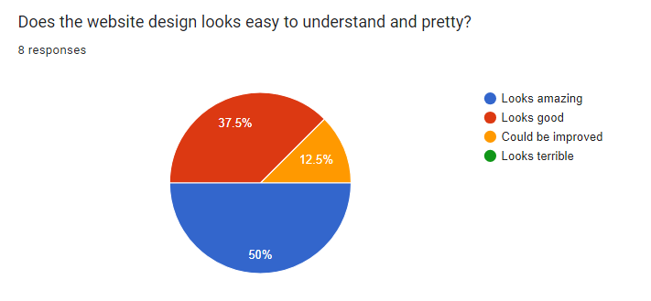

3.Did you have trouble logging in or signing up?  
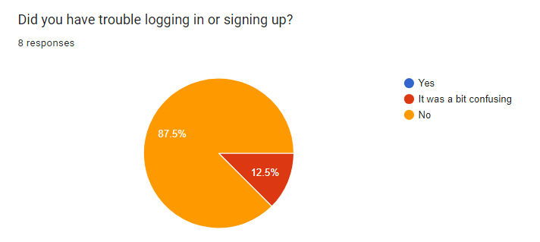

4.Did you encounter issues when managing your accommodations (creating, updating, deleting ) ?  
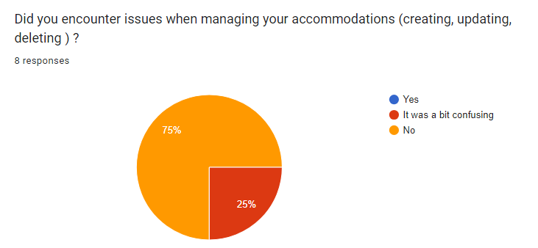

5.Was it easy to purchase and see your new accommodation?  
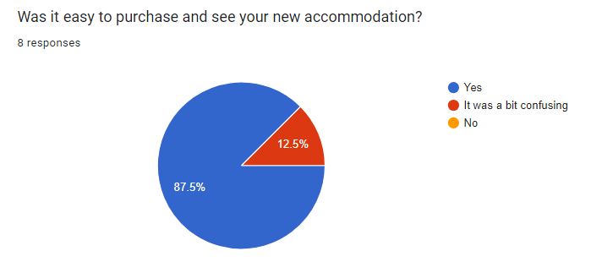

6.What did you think of the notification feature?  
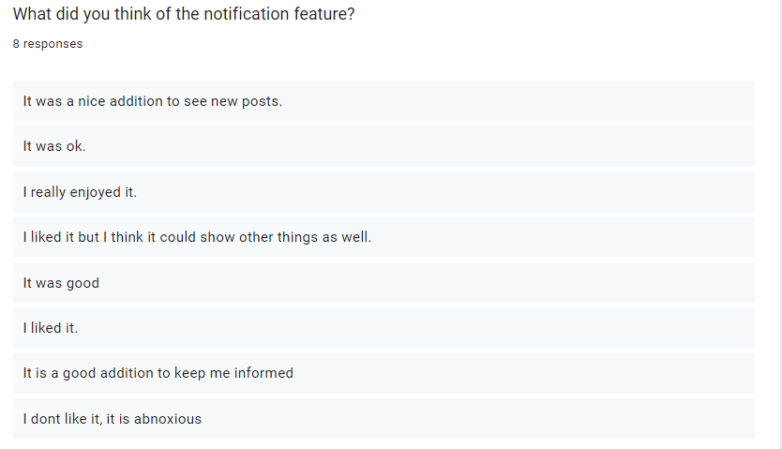

7.If you could improve the website, what would you suggest?  
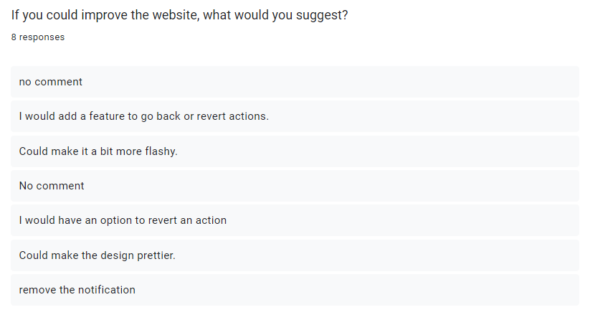

Strenghts and Reccommendations in my application:

This UX feedback report aims to evaluate the user experience of Realty Hub based on Nielsen & Molich's 10 Design Principles. After the poll was conducted, I came up with the following results. The report highlights the strengths and areas for improvement in each design principle.

Visibility of System Status:

**Strength**: The system effectively communicates its status to the users through clear visual cues and feedback messages. Users reported feeling confident about the progress and actions taken within the system.

**Recommendation**: Enhancing the visibility of system status in certain areas, such as long-loading processes, to avoid potential user frustration.

Match Between System and Real World:

**Strength**: The design employs familiar and recognizable language, symbols, and conventions, facilitating user understanding and reducing cognitive load. Users found it easy to relate system features to real-world scenarios.

**Recommendation**: Continue to maintain consistency in the usage of real-world concepts and language throughout the system.

User Control and Freedom:

**Recommendation:** Users would appreciate the presence of “are you sure” functionalities and clear navigation options, allowing them to recover from errors and freely explore various parts of the system. Also ensure there are undo/redo functionalities within the application.

Consistency and Standards:

**Strength**: The design adheres to consistent layout, typography, and color schemes, creating a cohesive and visually appealing experience. Users were able to navigate different sections of the system seamlessly.

Error Prevention:

**Strength**: The system effectively prevents errors by providing informative error messages, confirmation dialogs, and validation mechanisms. Users found the error handling to be helpful and intuitive.

Recognition Rather Than Recall:

**Strength**: The design prominently displays relevant information, reducing the need for users to recall previous actions or information. Users appreciated the visibility of key details and found it easy to pick up where they left off.

Flexibility and Efficiency of Use:

**Strength**: The design accommodates both novice and expert users by providing shortcuts, customizable features, and efficient workflows. Users with varying levels of expertise reported being able to work at their desired pace.

**Recommendation**: Consider conducting user research to identify additional opportunities for customization and efficiency improvements to cater to expert users.

Aesthetic and Minimalist Design:

**Recommendation**: Continue to refine the visual design, paying attention to whitespace, typography, and overall simplicity while maintaining the necessary functionality.

Help Users Recognize, Diagnose, and Recover from Errors:

**Strength**: The system provides clear error messages with suggestions for resolution, helping users understand and recover from errors efficiently. Users appreciated the guidance provided during error scenarios.

**Recommendation**: Review the error messages across the system to ensure clarity and provide more specific guidance for error resolution where possible.

Help and Documentation:

**Recommendation**: The system should include context-sensitive help options, tooltips, and easily accessible documentation. Consider implementing interactive tutorials or guided tours to further assist users in understanding the system's features and functionalities